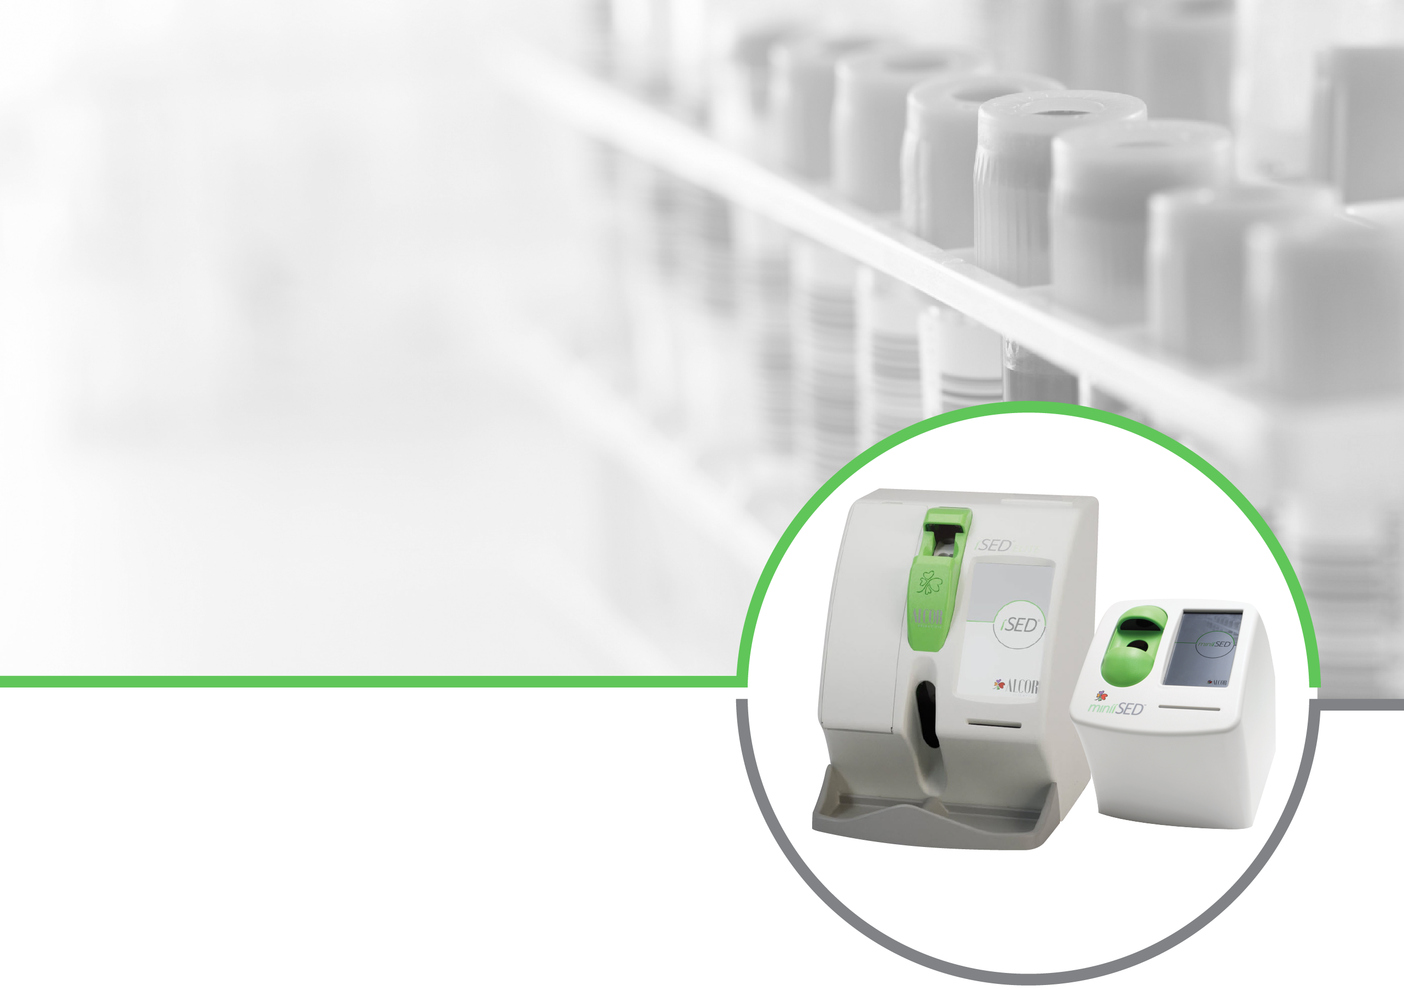
ALCOR® ESR ANALYZERS
Frequently Asked Questions

General Product Information

- What is the testing time?
The miniiSED® test time is ~15 seconds and the iSED® / iSED ELITE® test time is ~20 seconds for blood samples.

- How much sample is used per test?
100 microliters for the blood sample and controls.

NOTE: To ensure accurate results patient samples must be well mixed prior to testing. If automated mixing is not available (or enabled) on the analyzer, samples must be mixed manually or by mechanical rocker for a minimum of three (3) minutes before testing. Testing should occur immediately after mixing to ensure accuracy of the results.
- What tubes are compatible with the analyzers?
ALCOR analyzers are compatible with any standard 13x75 mm EDTA tubes with pierceable caps.
The analyzers are also compatible with the following pediatric tubes: the Microtainer MAP Tube from Becton Dickinson and the MiniCollect Complete Tube from Greiner Bio-One.

- What is the minimum collection tube volume?
500 microliters in standard EDTA tubes.
For non-standard or pediatric tubes, please follow the manufacturer’s recommendation.

- What is the recommended mixing time before running a patient sample?
To ensure accurate results patient samples must be well mixed prior to testing. If automated mixing is not available (or enabled) on the analyzer, samples must be mixed manually or by mechanical rocker for a minimum of three (3) minutes before testing. Testing should occur immediately after mixing to ensure accuracy of the results.
When testing with the iSED/iSED ELITE analyzer, no external mixing is required. All samples are automatically mixed for three (3) minutes (180 rotations) when loaded into the analyzer.

- How many samples can be loaded at the same time?
The miniiSED accommodates one (1) sample at a time.
The iSED/iSED ELITE accommodates up to twenty (20) samples simultaneously. The iSED/iSED ELITE is a continuous feed analyzer that allows for random access of sample insertion. If additional samples are inserted once testing has begun on previously loaded samples, the mix and test time for the samples in progress is unaffected.

For both analyzers, once the tube has been tested it is automatically returned to the user for additional laboratory procedures.

- What is the measurement range?
The measurement range is 1 to 130 mm/hr.

- How are patient ID’s entered?
Patient ID’s are read by the internal barcode reader or may be entered manually via the touch screen keypad.

- What happens if a sample is entered, but it does not have a recognizable barcode, or the Patient ID hasn’t been manually entered?
The analyzers will automatically assign an 8-digit identification number to the sample.

- Are the analyzers LIS compatible?
Yes, the analyzers are LIS compatible and the communication protocol is compliant to LIS2-A2 standard.

Technology

- What is the principle of measure utilized by the analyzers?
ALCOR analyzers use advanced Rheology Technology to measure the “earliest and most critical phase” of the Erythrocyte Sedimentation, which is called rouleaux formation. The rouleaux formation is the critical phase of ESR and the one that ultimately determines the rate at which the red cells will settle in the Westergren tube. The technical innovation of ALCOR analyzers consists of “directly” measuring the aggregation of the red blood cells, whereas the traditional ESR methods “indirectly” measure the aggregation of the red blood cells by recording the length at which the red cells settle in a Westergren tube. After measuring the aggregation directly, ALCOR analyzers produce ESR results in mm/hr. Utilizing EDTA blood from the primary tube, results are reported within seconds.

- Do any external factors affect the results?
ESR results obtained using ALCOR analyzers are unaffected by the variables commonly associated with traditional ESR testing, such as temperature, vibration, and operator variability. However, you should not place the analyzers on a bench experiencing extreme vibration.

- Are the results affected by hematocrit?
When measuring ESR using the traditional gravitational methods, such as the Westergren method, the value of the hematocrit is the most important variable. In fact, a low hematocrit will give a falsely elevated ESR result which does not reflect the true inflammatory state of the patient and an adjustment to the data is required (Fabry, 1987). [2]
ALCOR analyzers employ a direct measurement and is consequently less affected by the hematocrit. Understanding this advantage is important when comparing the analyzers with Westergren and modified Westergren methodologies.

- Are results affected by lipemia, hemolysis, or other conditions of the patient?
Extreme lipemia changes the viscosity of the sample, interfering with the measurement. ALCOR analyzers give an error message if it detects a drastic change. If hemolysis has occurred to such a degree that aggregation of RBC’s has been reduced, it will affect the results.
Sickle cell anemia and multiple myeloma are two conditions that are incompatible with an accurate ESR result when using both the Westergren method and ALCOR analyzers. The ESR value is increased in cases of multiple myeloma, but it is not related to an inflammatory response, it is due to the hypercalcemia condition associated with multiple myeloma patients. This is not a downfall of the analyzers, but laboratorians should be aware of the interference multiple myeloma has on any ESR measurement.

- How do the analyzers handle a specimen that may contain a clot?
ALCOR analyzers use a differential measurement system that is designed to be unaffected by micro clots. Therefore, a static clot does not interfere with the final measurement. The needle used in ALCOR analyzers is designed to prevent interfering clots from being aspirated into the hydraulic circuit and reading cell. If a clot prevents the sample from aspirating, the analyzers will retry the aspiration process three (3) times before it gives an “unable to withdraw” error code and aborts the test. Following an error, a washing procedure is automatically preformed to remove any potential clots. Up to three (3) washing attempts are performed to remove clots before giving a “wash not OK” error code. Lastly, there is a simple bleaching procedure available to clean the line if the automatic wash is not able to clear the instruments.

Accessories

- What is a test card?
A test card is a small smart card which contains a pre-determined quantity of test credits, similar to a prepaid phone card. Once inserted into the analyzer, the tests credits will be transferred from the test card to the instrument and the total available test credits will be displayed on the screen
- Are quality control tests deducted from the test counter?
Yes, the quality control tests are processed and counted as normal samples.

- How do operators know how many tests are loaded?
ALCOR analyzers have built-in test counters. The number of remaining tests can be found on the display screen.

- What is the composition of the wash required for use with the analyzers?
The wash meets the CLSI standard for Clinical Laboratory Reagent Water (CLRW) (formerly Type 1 Ultra-Pure Water) which is ion free, bacteria free, and organic free.

- What is the shelf life of the wash?
Twelve (12) months.

- How often is a wash cycle performed?
A wash cycle is run once after fifteen (15) minutes of non-use or can be performed on-demand as needed. The miniiSED will run a wash cycle automatically once the instrument is powered off via the power button on the rear of the device.

- Is a wash cycle run or required after every test?
No. The first ninety (90) microliters of each blood sample are used to remove carry-over from the prior sample. The next ten (10) microliters of blood are used for testing.

Seditrol® Quality Controls

- What controls do the analyzers use?
Seditrol Quality Control (QC) is human-based whole blood quality control.

- How many times per day should QC be run?
It is up to each individual lab to determine the quantity and frequency of controls per an Individualized Quality Control Plan (IQCP), as recently established by CMS, CAP, and COLA.

- Does the Seditrol QC need to be refrigerated?
No. Seditrol QC should be kept at room temperature (18° to 30° C), even after piercing.

- What is the open vial stability of Seditrol QC?
The open vial stability of Seditrol Quality Control is sixty (60) days after the first piercing.

- What is the unopened shelf life of Seditrol QC?
The unopened shelf life of Seditrol QC is eighteen (18) months from the date of manufacture.

- What is the test time for controls?
Seditrol QC requires more mixing than patient samples because the control material matrix is very viscous compared to fresh, whole blood samples. It is recommended that each tube of Seditrol QC be mixed for a minimum of twenty-five (25) minutes prior to first use on an ALCOR analyzer to ensure the resuspension of packed cells for a homogenous sample. For each subsequent QC event after the first initial use, QC samples should be placed on a mechanical rocker or rotator for at least 5 minutes before placing the control tubes onto the ALCOR analyzer.
When using the miniiSED, test time for Seditrol QC is five (5) minutes, after adequate mixing as described above.
When using the iSED/iSED ELITE, the test time for Seditrol QC is three (3) minutes, following a five (5) minute automated mixture cycle.

- Do the analyzers detect if the control test performed is within range?
No, the user must compare results to the Seditrol package insert.

- Can the analyzers detect if the controls have expired?
No, the user must compare results to the Seditrol package insert.
- How many reading sensors do the analyzers have to QC?
ALCOR analyzers utilize a single reading sensor for analysis and therefore 100% quality control of the analyzer is performed whenever QC is run.

Blood Sample Handling

- How soon must the test be performed after the blood sample is drawn?
According to the CLSI guideline; blood drawn from the patient directly into EDTA tube is stable to test within four (4) hours from venipuncture and up to twenty-four (24) hours, if refrigerated. [1]

- Do blood samples need to be brought to room temperature before use?
Yes. This usually takes about 15 minutes. Please check with your specific laboratory’s standard operating procedures for blood sample handling.

Calibration

- How is the device calibrated?
The calibration of the analyzers is performed during the manufacturing process by the manufacturer and never needs calibration at the laboratory. The device also performs a self-check of the photometric system after each wash cycle. The self-check will compensate for variability of the reading cell and the wash solution but will also alert the operator with an error message (“Washing Error”) when the self-check fails.

- Is an external calibrator required?
No, an external calibrator is not required.

Routine Maintenance

- Do the analyzers require any routine maintenance?
There is no required daily or weekly maintenance. The analyzers require a deep cleaning procedure utilizing a seven percent (7%) bleach solution monthly or every 1000 tests, whichever comes first. The deep clean is fully automated and takes only (five) 5 minutes to perform. Depending on your laboratory’s testing volume, a sample needle replacement and/or peristaltic pump tubing replacement may be required.

- When should the sample needle be replaced?
It is recommended that the sample needle be replaced after 30,000 test aspirations. Please contact Technical Support for instructions on replacing the needle.

References

[1] CLSI. (2011) Procedures for Erythrocyte Sedimentation Rate Test; Approve Standard – Fifth Edition. CLSI document H02-A5. Wayne, PA: Clinical Laboratory Standards Institute

[2] Fabry, T.L. (1987) Mechanism of erythrocyte aggregation and sedimentation. Blood, 70, 1572-1576

The analyzer requires an additional 50µL of sample on the first test following a wash cycle.

